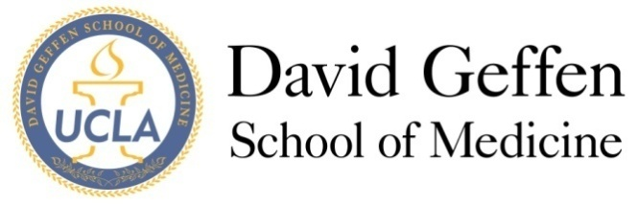
Medical Student Council
Meeting Agenda: April 9, 2013
- MSC Meeting - Welcome and Quorum
- Approval of the Minutes
- Officer Reports
- Committee Reports
- New Business
ITEM A: AAMC Graduation Questionnaire –Luann Wilkerson, Ed.D.
ITEM B: PCP Student Organization Application—Maggie Chen & Max Goldstein
ITEM C: Innovations Officer Proposal—Pooja Upadhyaya
ITEM D: Google groups discussion—Chris Redgate
ITEM E: Student organization renewal appeals—Sybil Zachariah
ITEM F: Geffy Guide—Sarah Young
ITEM G: Humanism Award—Sybil Zachariah
- Adjournment
- Reflections

