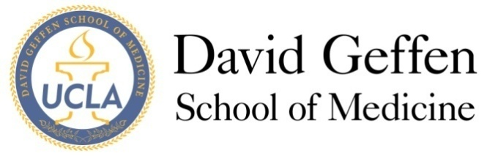
Medical Student Council
Budget Committee
Tuesday, July 1st, 2014
AGENDA
- Open Meeting- 19:08
- Introductions
- Budget Update
  - Amount spent last month: $0
  - Amount of budgeted funds remaining: $25,000
  - Amount actually spent: $0
- Old Business
- New Business
  - Expectations/Goals for year
  - Robert’s Rules
  - Discussion of 2014-2015 Committee Guidelines and revisions
- Proposals (see below)
  - Class of 2015 Barney’s Social Night- Monday, July 7th, 2014
  - Class of 2015 Beach Social Night- Friday, July 11th, 2014
- Other issues
  - Retreat on Sunday, July 13th
- Adjournment- 20:30
- Reflections

Proposals
 | Organization | Proposal Author  & Advisor | Date/Time  Location | Event Title | Total Amt Desired | Issues
1 | Class of 2015 Social Committee | Scott Greenberg | 7/7/14, 7pm | College Foundations Barney’s Social | Social Fund:  $300.00  (itemized budget attached) | None  Has $1000 remaining
2 | Class of 2015 Social Committee | Scott Greenberg | 7/11/14, 7pm | College Foundations Beach Social | Social Fund:  $200.00  (itemized budget attached) | None  Has $1000 remaining

