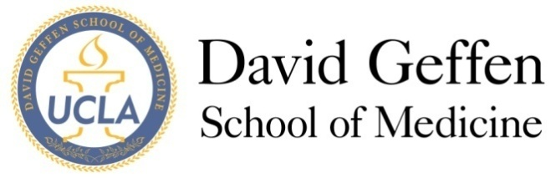
Medical Student Council
Meeting Agenda: March 12, 2013
- MSC Meeting - Welcome and Quorum
- Approval of the Minutes
- Officer Reports
- Committee Reports
- New Business
ITEM A: Proposed Change in Professional Fees for the 2013-14 Academic Year—Dr. Neil Parker
ITEM B: 4th year banquet budget request for GSA
ITEM C: Innovations Competition Finalists – Kevin Ikuta
ITEM D: Student Org Renewal—Sybil Zachariah
ITEM E: Geffy Guide—Sarah Young
ITEM F: Humanism Award – Gil Weintraub and Kris Roberts
- Adjournment
- Reflections

