MS2 November/December Survey Results

- Are you for or against adding a 6 week clinical clerkship during fourth year?
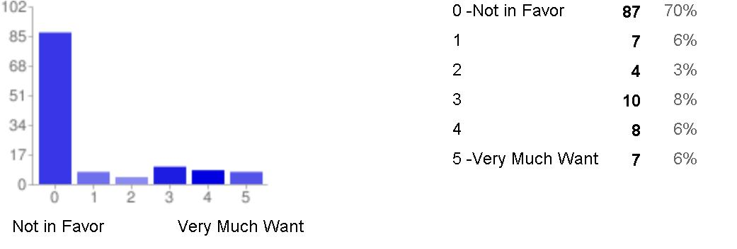
Note: this issue hasn’t been brought up to the MEC again since the September meeting, and no voting has yet occurred.

- Comments on the added 6 weeks:
Make it optional (23)
Want time off instead (12)
Replace other items in curriculum to make space (4)
Change other items in curriculum to accomplish same goal (3)
Make it shorter than 6 weeks (2)
Make it only for those who need it (1)
Afraid of late graduation (1)

- What improvements would you like to see to the curriculum?
More USMLE step 1 Review/focus (10)
More Morning lab/free afternoon (6)
Student input for changes/Admin and Faculty do not listen (6)
More biochem (4)
More efficient use of time, Reduce details that are unneeded, 100+ slides (3)
More clinical skills (2)
More embryology-have Wisco teach it (2)
Less PBL/LI time (2)
More winter break vacation time (2)
More clinical judgment (1)
More flexibility/not everyone needs to go to afternoon labs(1)
More genetics(1)
Policies hard to find/understand(1)
SOAP and H&P is poorly defined (1)
Standardized patients for pelvic exams (1)
Input about MS3 rotations (1)
Review of systems earlier (1)
More patient time during years 1 and 2 (1)
Remove pass/fail (1)
Make PBL review previous blocks material too (1)
Integrate material from year 1 (1)
Less touchy-feely readings and more basic science (1)
Lectures on alcohol and tobacco abuse (1)
More practice problems to solidify knowledge (1)
Outlines of lectures should be more uniform (1)
Less delay in uploading lecture (1)
LI and PBL tutors improvement (1)
Lectures who do not know what we have done (1)
Remove Best Bets (1)
Make information from UCLA available for Riverside too (1)
Preceptorship should allow non primary care (1)
More efficient use of time (1)
Divide up long blocks (1)
Review of medical system (1)
Better lectures (1)
Immediate feedback on lectures for instant corrections(1)

Question 3 Summary:
- Step 1 Review
- Communication

- Basic Sciences
- Repetition/Practice

- Time/flexibility

- What is your #1 curriculum gripe right now?

Schedules (13)
Post required events earlier
Short winter break/ changed calendar (8)
Consult students on schedule changes
More free days (to let us shadow) (2)
More time to study for exams

Labs (12)
Make more interactive
Cut them out, give more independent study time / waste of time (9)
Make them optional
Make them more efficient

Curriculum content (12)
More biochem
More real patient contact/ earlier preceptorship (2)
More focus on primary care issues
More USMLE prep (8)
Add Step 1 Qs to finals
Add USMLE topics list to lecture outlines
Make assessments more in tune w/ USMLE content/style
More biochem and embryo
Integrate boards prep into block curriculum (3)
Discuss openly to relieve anxiety

Doctoring (7)
Decrease # readings for doctoring
More interviewing and H&P writing; less discussion (2)
Make more relevant to role MS2-4
OSCE grading not objective and variable
Correlate OSCEs with skills learned (e.g. review MSK exam if it’s part of an OSCE)
Have sessions once per month

PBL (6)
Allow great flexibility in style of learning issue write-ups (3)
Make PBL once a week/ make more time efficient (2)
Evaluations not objective or standardized (1)

Admin (5)
Make evaluations more transparent
Allow students to see missed exam questions
Put greater value on student input
Have lecturers hold office hours
Greater curriculum transparency with students (share data and MedEd study results)

Lectures (4)
Ppts too long (keep to < 50 slides for 50 minute lecture)
Make lectures relevant and effective (2)
Have more lecture time

December MS2 MEC Reps Survey Results
Responses: 71

5. Interested in Anatomy sessions?
Yes: 64
No: 5

Times?
Monday PM: 45
Tues AM: 39
Weds AM: 38
Thurs AM: 37
Friday PM: 28

Topics?
Neurovascular (including plexuses): 17
MSK: 9
GI/Digestive system: 8
Cardio: 7
Pelvis/GU: 7
Boards topics: 5
Cranial nerves: 5
Neuroanatomy: 5
H&N: 4
Prep Files: 4
(specifically asked to have them made available)
Pulmonary: 2
Abd wall: 2
Surgery/clinical anatomy selective: 1
(specifically requested)

6. Other complaints?
- Need more help and guidance with boards prep (5)
- Want prep Files / high-yield boards review packet (5)
- Histopath labs have poor format (poor room choice, put it in a lecture hall) (4)
  - Dr. Dry’s format better – use as model (2)
- Want more flexibility with PBL Learning Issues (choice of outline, powerpoint presentations, or standard write up format; more cases/wk) (3)
- Poor lecture quality / encourage faculty lecture notes (2)
- Nutrition labs need revamping (1)
- Need clinical skills review of MSK (1)
- Doctoring sessions too formatted/ not enough flexibility (but useful) (1)
- Want Yr 2 drug flash files (1)
- Want embryology review (Wisco?) (1)
- Want anatomy review during MS3 orientation (1)
- Too many exam questions based on fact recall (1)
- Teaching MSK through self-directed flash files wasn’t helpful in Block 4 (1)
- OSCE feedback not helpful (1)
- Want more Dr. Peacock (1)
- Want more integration between blocks (1)
- Too much emphasis on academic medicine (1)
- Not enough focus on generating patient-centered differential diagnoses (1)

