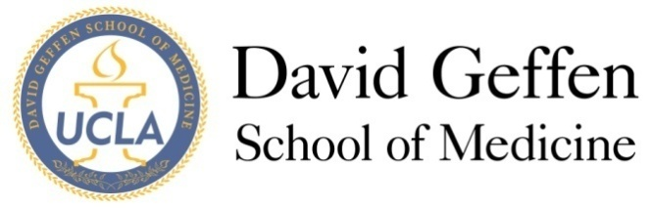
Medical Student Council
Agenda
October 8th, 2013
- MSC Meeting - Welcome and Quorum
!!!!~~WELCOME 1ST YEAR MSC MEMBERS~~!!!!
- Approval of the Minutes
- Issues from the Student Body
- Officer Reports
MS1, MS2, MS3, MS4, Drew, Prime, MSTP, Riverside, SAO
- Subcommittee Updates and Reports
- Student Interest Group (Max)
-See below for discussion point
B. Med School Winter Banquet (Chris)
C. Geffy Guide (Sarah)
D. Humanism in Medicine Residents Award (Christine)
-See below, read the attached document and be ready to discuss
- New Business
ITEM A: (Possible) 1st Year Community Building LunchRoulette
Jack Tian & Robert Marlin
- Adjournment
- Reflections
*Attachments:
1. Humanism in Medicine Residents Award – Form
2. Humanism in Medicine Residents Award_draft_MSC

Further Explanation
A. Subcommittee: Student Interest Group (Max)
Here are the areas of interest that will be targeted via 2 SIG surveys:
Survey 1: All students
1) Are students satisfied with SIGs on campus?
2) Do SIGs promote learning outside of the classroom (verbatim language from our constitution)
3) Do students want more workshops and activities, or are they ok with just lunch talks
Survey 2: SIG leaders
1) What SIG leaders got out of their leadership experience
2) What were some of the greatest challenges as a SIG leader

D. Subcommittee: Resident Professionalism Award (Christine)
The residents award subcommittee has developed the following proposal for an award presented by DGSOM medical students to residents for their excellence and contributions to medical education in teaching, mentorship, and the establishment of a safe and medical student friendly learning environment. We are seeking the MSC's support and suggestions before finalizing the details thereof with Joyce Fried and the Dean's Office. Please look within the document, there are comments reflecting some points of discussion for the MSC.

