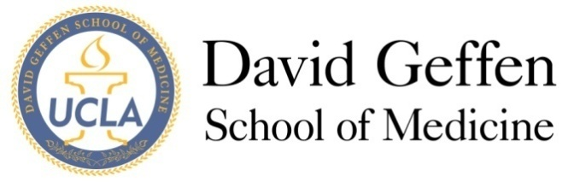
Medical Student Council
Agenda
November 12, 2013
- MSC Meeting - Welcome and Quorum
- Approval of the Minutes
- Issues from the Student Body
- Officer Reports
MS1, MS2, MS3, MS4, Drew, Prime, MSTP, Riverside, SAO
- Sub/committee Report
- Student Interest Group (Max) Potential MSC Vote
-Presentation of Survey Data with discussion and Q&A (ppt)
-Report of all data to be sent out 1-2 days before the meeting*
- Med School Winter Banquet (Chris) Potential MSC Vote
-Update on possible venues with discussion (ppt)
-Possible vote on which venue will hold event
- Geffy Guide (Sarah)
- Humanism in Medicine Residents Award (Christine) MSC Vote
-Update on current status of award – finalized details
-Vote of support for award by the MSC
- New Business
ITEM A: Wellbeing Winter Event (Amy, MS4) MSC Vote
-Proposal Attached
ITEM B: OSR Announcement (Alfred, MS2)
ITEM C: Potential MSC funding proposal (Ezra, MS1)
ITEM D: Dr. Elizabeth Yzquierdo Farewell + Party (Chris, MS4)
ITEM E: Grading Forum- Website Info and Updates (Chris, MS4)
- Adjournment
- Reflections

*Attachments:
1. Wellbeing Winter Event Proposal

Further Explanation

*Look for the Student Interest Group survey results report that will hopefully be sent out before the meeting (there is a lot of data but the report is coming along!)

