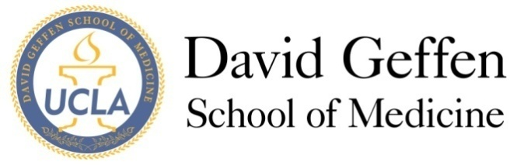
Medical Student Council
September 10, 2013
Agenda
MSC Meeting called to order at 7:08pm by President Chris Redgate
- MSC Members Present: Chris Redgate, Sarah Young, Gil Weintraub, Christine Thang, Nina Vyas, Abraar Karan, Alfred Yoon, Alexa Merz
- Staff/Faculty present: Dr. Parker, Meredith Szumski, Mitsue Yokota

- MSC Meeting - Welcome and Quorum: “The choices we make reveal the true nature of our character”

- Approval of the Minutes: motion approved unanimously

- Issues from the Student Body: none to report

- Officer Reports :
a) MS2s: End of block 6, working on service project (antic. Date in January), puppy therapy tomorrow (Wilson lounge at lunchtime, meet a puppy!), wellness group meetings coming up this month, Med Games Sept. 28th with social at Busby’s after
b)MS3s: On clinical rotations, post-surgery shelf celebration at Q’s in 3 weeks
c)MS4s: One week away from submitting residency applications, recent alumni/current student mixer on Saturday was a huge success
d)Drew: Project Santa Clause in December
e)Prime: Introduction to prime program, no updates
f)Riverside: Just opened up their medical school
g)SAO: tutoring programs in the works (pilot programs on weekends), mentorship opportunities being discussed, livescan/TB/fingerprinting issues for clinical rotations—trying to accomplish these things during foundations week or at a more convenient time for students

- Subcommittee Updates and Reports
- Student Interest Groups
  - Three subcommittees have been formed in conjunction with OSR reps to gather data/info about what other schools are doing with regards to interest group successes and pitfalls.
- Med School Winter Formal (Chris)
  - February 2nd 2014
  - Venue ideas to be collected over the next 2 weeks by the subcommittees and other volunteers
  - Plan to vote on a venue at the next meetings
- Geffy Guide (Sarah)
  - For-students, by-students guide, in final stages of editing (thanks Abraar and Alfred!)
- Budget committee
  - Funded $4000 of student activities/meetings/conference attendance
- New Business
I) ITEM A: Award Proposal (Joyce Fried)
- UCLA has been working diligently to encourage a healthier and more learning friendly environment for medical students while fostering better relationships between residents/faculty/med students
- Hoping to develop a proposal that to establish rewards for “model” behavior on behalf of residents instead of threatening them with repercussions for poor behavior
-Plan to develop a subcommittee to develop awards for outstanding residents at all UCLA affiliated site
- Subcommittee leader: Christine Thang (contact for more info on volunteering to be a part of the proposal development). Other volunteers: Gil Weintraub, Alexa Merz

II) ITEM B: Wellbeing Funding (Wellbeing Coordinators + Mitsue)°
- Currently, funding from student scrub sales is allocated for one Winter and one Summer well-being event (or one large event)
- BUY SCRUBS FROM THE HEALTH SCIENCE STORE for more well-being events
- Majority of funds to come from fundraisers; for extra funds, well-being reps can apply through the budget committee

III) ITEM C: MS3 Grading Changes (Update)
- E-mail to be sent out to student body soon with updates
IV) ITEM D: New Vice Dean of Education, Clarence H. Braddock III, M.D., M.P.H.
- Welcome!
- Survey to be sent out to student body regarding medical school education likes and dislikes

- Adjournment: motion to adjourn passed unanimously

- Reflections

This meeting was adjourned at 8:25pm by Chris.

Further Explanation

°ITEM B: Wellbeing Funding
-Previous wellbeing funds have come from scrubs sales (started by C/O 2011)
(Budget in 2010: $3000, 2011 & 2012: $2000)
-First meeting with all Wellbeing reps in October, at which time they will submit itemized proposal for spending of funds
*Question for the MSC: Will there be an allocation of funds this year? If so, how much?

