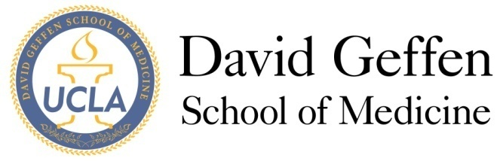
Medical Student Council
Meeting Agenda: September 11, 2012
- MSC Meeting - Welcome and Quorum
- Approval of the Agenda
- Introductions, Mission, Vision, and Expectations for the year—Sybil Zachariah (10 min)
- Officer Reports (5-10 min)
- Committee Reports
- Budget Committee Report – Kevin Ikuta (5 min)
- New Business
- ITEM A: Position description constitutional amendments—Sybil Zachariah (10 min)
- ITEM B: Budget Committee bylaw amendments—Kevin Ikuta (5 min)
- ITEM C: SIG/SC description constitutional amendments—Sybil Zachariah(10 min)
- ITEM D: C/o 2015 service project—Max Dean Goldstein (5 min)
- ITEM E: Geffy Guide—Sarah Young (10 min)
- Columnists
- Deadlines
- ITEM F: Well-Being funding—Kevin Ikuta (5 min)
- ITEM G: Ultrasound curriculum addition to preclinical years – Christina Kopriva (5 min)
- Adjournment
- Reflections

